## Year 11 General Psychology

UNIT 1, TASK 5 – COMMUNICATION

Name of Student: _____________________________________ Due Date:

|  |  |
| --- | --- |
| Course Outcomes: | **1:** Psychological Understanding  **3:** Applying and Relating Psychological Understandings  **4:** Communication in Psychology |
| Assessment Type: | Project |
| Assessment Weighting: | 6% of Unit 1 |

**OVERVIEW OF TOPIC:**

You have applied for a job as an educational assistant at a high school. The job application asks for a summary of your basic knowledge of the difference between AUSLAN and Key Word Sign (formerly known as Makaton). To answer this question correctly, you decide to research on both forms of sign language.

**TASK:**

The aim of the task is to increase your psychological knowledge on communication and to apply your understandings to using sign language. You will demonstrate this by researching the below information and present your findings to the class. The day after your submission of this assessment you will sit a validation to assess your understanding of the topic.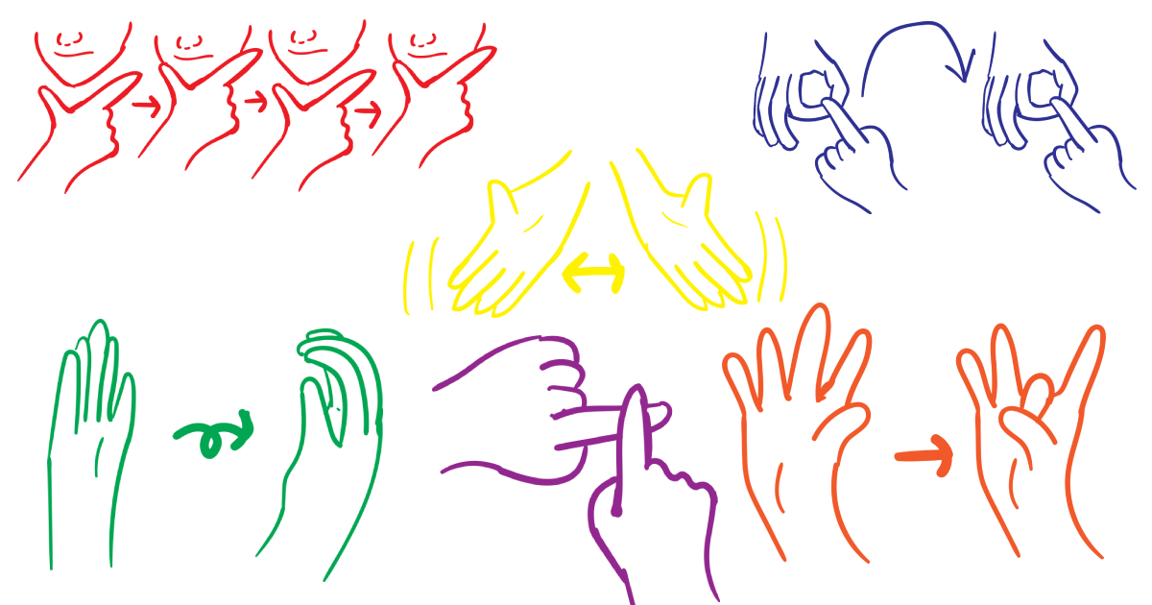

You will need to include:

* AUSLAN:
  + Describe what AUSLAN is (1)
  + Brief history (1)
  + Describe why AUSLAN is used (1)
  + Describe who would use AUSLAN (1)
  + Describe an appropriate method for teaching new signs to a person for the first time. (1)
  + Be able to sign
    - First name, age and country you were born in (3)
* Key Word Sign:
  + Describe what Key Word Sign is (1)
  + Brief history (1)
  + Describe why Key Word Sign is used (1)
  + Describe who would use Key Word Sign (1)
  + Describe an appropriate method for teaching new signs to a person for the first time. (1)
  + Be able to sign while speaking clearly
    - First name, age and country you were born in (3)

Marks will also be awarded for visual presentation and oral presentation skills. (4)

**

Part A: report submitted ass a PDF answering the points above

Part B: Validation (20 marks)

* In-class, 30 mins on the topic of communication
* No notes allowed